Tutorial – 02

Step 1: Understand and Define the Problem (Analyze)
Design a combinational logic circuit that operates an alarm in a car whenever driver or/and passenger seat/s are occupied.
The alarm must be activated in the following scenario/s.
- When the ignition is on and the driver or/and passenger seat are occupied and either driver seat belt or passenger seatbelt or both are unfastened.

Step 2: Organize and Describe the Data
This has 5 inputs
- DRIV - Driver is present (=1)
- PASS – Passenger is present (=1)
- IGN – Ignition switch on (=1)
- BELTD – Driver seatbelt Unfastened (=0)
- BELTP – Passenger seatbelt Unfastened (=0)
One output
- ALARM – LOW (Alarm is ON)

Step 3: Plan the Solution (Design the Algorithm)

3.1 Algorithm (in plain English)
- Monitor ignition status (IGN = 1)
- Check if the driver is seated and belt is not fastened. (DRIV = 1 | BELTD = 0)
- Check if the passenger is seated and belt is not fastened. (PASS = 1 | BELTP = 0)
- If either of the conditions are TRUE, and IGN = 1, the alarm activates.
- Otherwise, alarm remains HIGH. (off)

3.2 Truth Table

DRIV | BELTD | PASS | BELTP | IGN | ALARM
0 | 0 | 0 | 0 | 1 | 1
0 | 0 | 0 | 1 | 1 | 1
0 | 0 | 1 | 0 | 1 | 1
0 | 0 | 1 | 1 | 1 | 1
0 | 1 | 0 | 0 | 1 | 1
0 | 1 | 0 | 1 | 1 | 1
0 | 1 | 1 | 0 | 1 | 1
0 | 1 | 1 | 1 | 1 | 1
1 | 0 | 0 | 0 | 1 | 0
1 | 0 | 0 | 1 | 1 | 0
1 | 0 | 1 | 0 | 1 | 0
1 | 0 | 1 | 1 | 1 | 0
1 | 1 | 0 | 0 | 1 | 1
1 | 1 | 0 | 1 | 1 | 1
1 | 1 | 1 | 0 | 1 | 0
1 | 1 | 1 | 1 | 1 | 1

3.3 Boolean Expressions (SOP)
DRIV.$\overline{BELTD}$.$\overline{PASS}$.$\overline{BELTP}$.IGN
DRIV.$\overline{BELTD}$.$\overline{PASS}$.$BELTP$.IGN
DRIV.$\overline{BELTD}$.$PASS$.$\overline{BELTP}$.IGN
DRIV.$\overline{BELTD}$.$PASS$.$BELTP$.IGN
DRIV.$BELTD$.$PASS$.$\overline{BELTP}$.IGN

ALARM = DRIV.$\overline{BELTD}$.$\overline{PASS}$.$\overline{BELTP}$.IGN + DRIV.$\overline{BELTD}$.$\overline{PASS}$.$BELTP$.IGN + DRIV.$\overline{BELTD}$.$PASS$.$\overline{BELTP}$.IGN + DRIV.$\overline{BELTD}$.$PASS$.$BELTP$.IGN + DRIV.$BELTD$.$PASS$.$\overline{BELTP}$.IGN

3.4 Flowchart
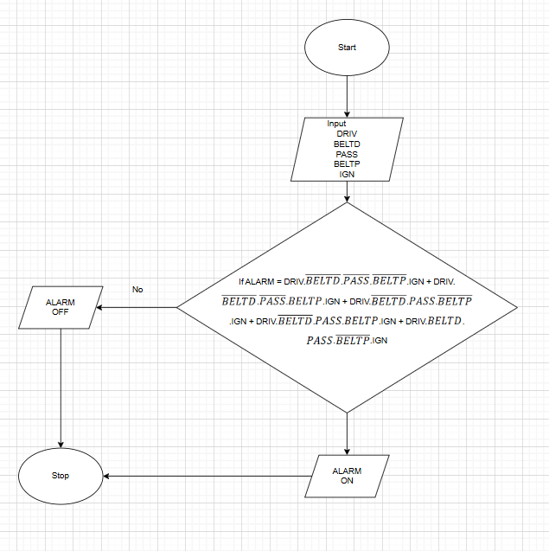

3.5 Pseudocode

START
GET IGN, DRIV, BELTD, PASS, BELTP
IF DRIV.BELTD. PASS. BELTP.IGN + DRIV.BELTD. PASS.BELTPIGN + DRIV.BELTD. PASS. BELTP.IGN + DRIV.BELTD.PASS.BELTP.IGN + DRIV.BELTD. PASS.BELTP.IGN
THEN ALARM = 0 # ON
ELSE ALARM = 1 # OFF
END

Step 4: Test and Refine the Solution (Debug and Verify)
